Handleiding MapGallery (admin manual?*6)

Table of Contents
1. Introduction Manual 1
1.1 Getting started 1
2. Administrator interface 1
2.1 Introduction (what do you see) 1
2.2 MapGallery*3 1
2.3 User Access 1
2.4 Configuration 1
2.5 Additional options 1
2.6 Links*7 1
3. Configure maps 1
3.1 Add maps (explain what these information are for *6) 1
3.2 Making maps*2 2
4. How to embed *2,7 (how to use) 2
4.1 Share 2
5. About MapGallery 2
5.1 Credits 2
5.2 Contact 2

0. Welcome page

1. Introduction Manual

1.1 Getting started

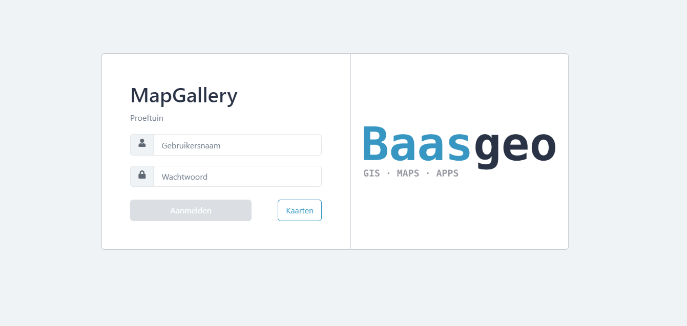
1.1.1 Log in screen

Username:
Password:
Change password (add forgot password feature)
https://docs.aspnetzero.com/en/common/latest/Features-Angular-Forgot-Password#:~:text=If%20a%20user%20forgets%20the,sent%20to%20entered%20email%20address.
Not a customer yet? Get in contact with MapGallery
- Administrator inlog

1.1.2 Maps *5(Public Maps)
Public gives you the opportunity to view published maps created by other MapGallery users
> How to use maps (user manual, for users from the client?*6)

2. Administrator interface
Once logged in, directly go to admin page, skip maps and make a button to view all maps instead
Logo → MapGallery Admin → breadcrumbs

2.1 Introduction (what do you see)
Admin page is divided in to four different components; General, Configure maps, Map options and links

2.2 MapGallery*3

2.3 User Access

2.3.1 Explanation to Users and User groups
(demarcate to admin view only?*3)

To add or edit users, press the button and fill in all the necessary fields to create a new user.
Select in the tab “Groups”,
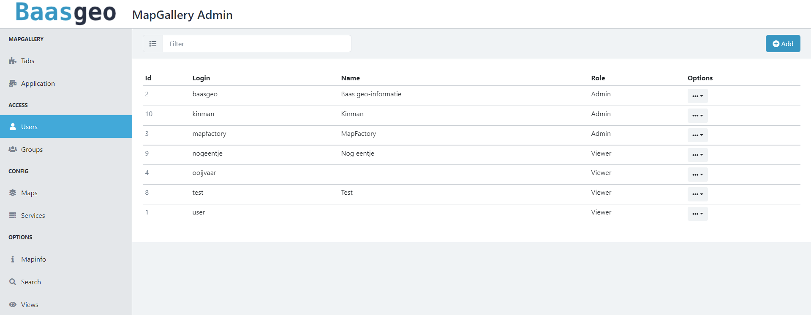
2.3.1.2 Roles of users

2.4 Configuration
2.4.1 > 3. Configure maps
2.4.2 Services*4
2.4.2.1 Services explanation
2.4.2.2 How to use services
2.4.2.3 What does the protocols mean

2.5 Additional options
2.5.1 Mapinfo*4 (>3.2 making maps)
2.5.2 Search*4 (>3.2 making maps)
2.5.3 Views*4 (3.2 making maps)

2.6 Links*7

3. Configure maps

3.1 Add maps (explain what these information are for *6)
3.1.1 Add title
Add a title to the map, the title will be displayed in the “Published Maps” section
3.1.2 Description
Add a description to your map
3.1.3 Image URL*5(Thumbnail)
Enter a URL for a thumbnail.
Add upload thumbnail feature?

3.2 Making maps*2
3.2.1 Settings
3.2.1.1 Explanation to all fields (and preview button)
Access Policy
Choose a for whom your map may be viewed by
Hide in overview (published maps)
Respects access policy but hides from Published Maps
Title
Subtitle*3
Description
View*3
Map info*4
Choose a map info layout for your map, more information about mapinfo > read 2.5.1 map info
Image URL
Tags*3
3.2.2 Layers
3.2.2.1 Explanation about how to use layers
Instead of ‘write new layer name then press new group’ change it to add new group button, then write a name
Add layer button
Press the dropdown menu to edit, delete or copy to clipboard (>3.2.2.2)
Add layer
Service
Choose a service where you’d want a layer to be added in the map, if you want to add another service. Go to >2.5.3 Service
Layername
Add
3.2.2.2 Hidden features (i.e. download, copy and paste)
Template (kan weg evt)
Paste
Copy all
3.2.3 Access Policy*2
3.2.3.1 Select all groups who are eligible to view the map
3.2.3.2 Explanation to the groups
3.2.3.3 Hide in overview -
3.2.4 Widget *4

3.2.5 Search*1(Search attributes)
3.2.5.1 Explanation to how and when to use this

4. How to embed *2,7 (how to use)
Congrats, you have made a map. But how to implement it into your own website *6

4.1 Share

5. About MapGallery

5.1 Credits

5.2 Contact

*1, Naam aanpassen
*2, Nieuw
*3, Vraag over functionaliteit (bart)
*4, Ergens anders?
*5, (huidige naam)
*6, Hulp met tekst
*7, nog aan te passen

